grants application
Completion Reports, V1.0

grants application

Completion Reports, V1.0

Step 1: Logging Into the Grants Application – Completion Report Portal

- Log into the MyGaDOE Web portal with the assigned username and password combination, and select Login.

- Using the right scroll arrow, adjust the display so that → Grants Application displays, selecting the Completion Reports option.

The Completion Report icon displays: 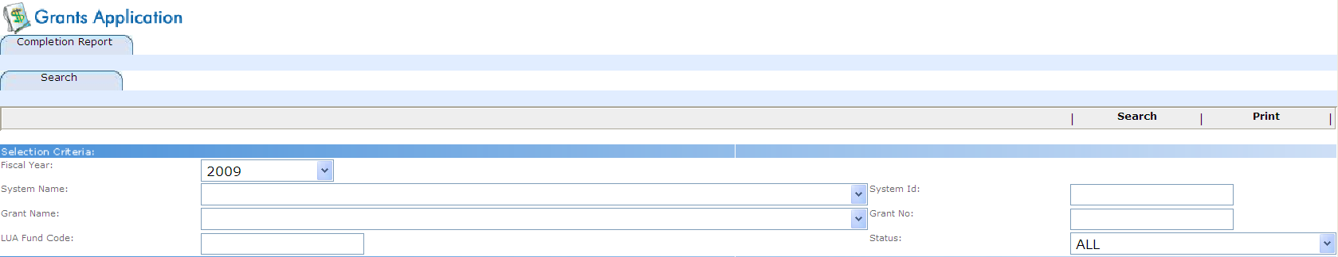

Step 2: Loading a New Budget
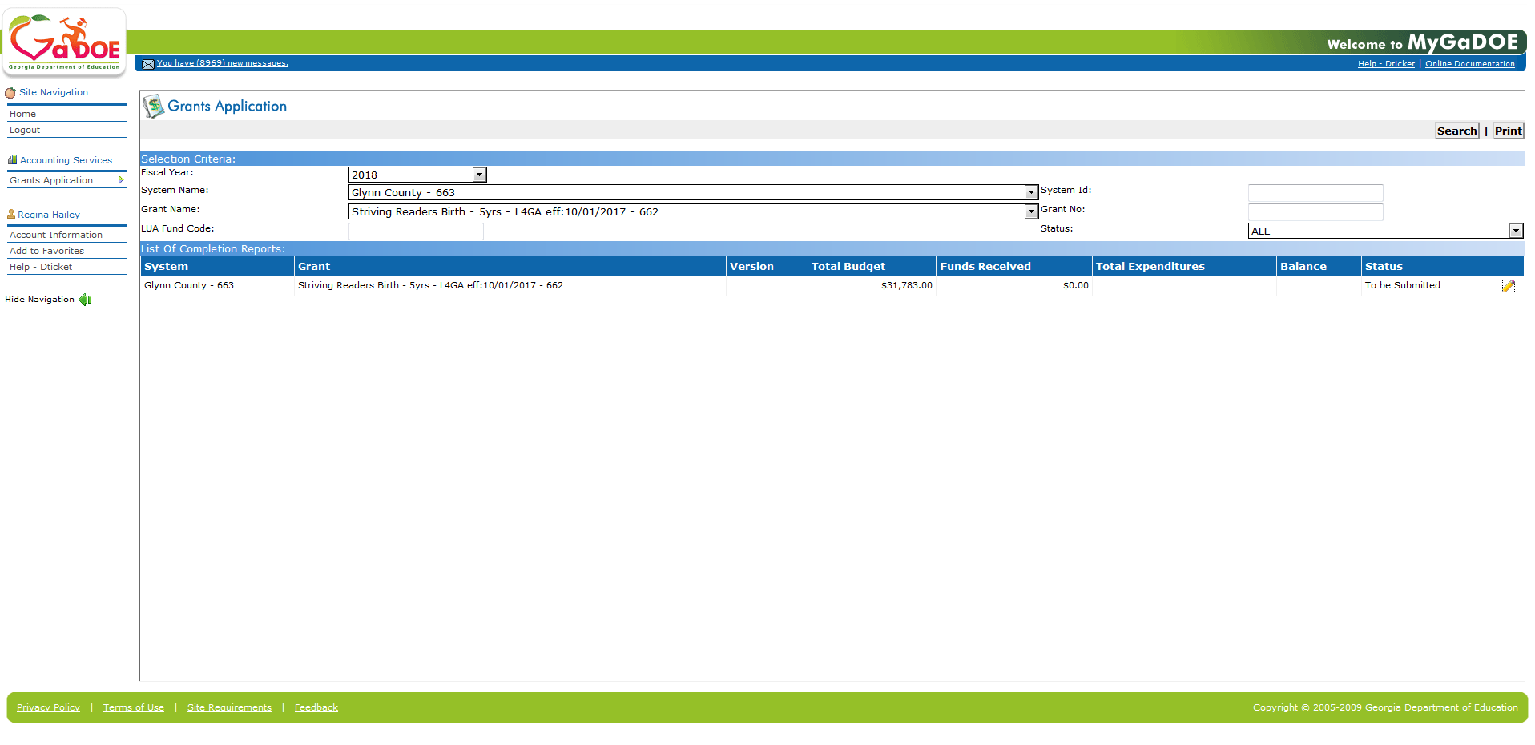
- On the Search tab, where appropriate:
- Choose the Drop-down selection icon within the Fiscal Year, System Name, Grant Name, and the Status fields.
- Enter the school system’s identifier in the System Id (System Identifier) field.
- Enter the grant number in the Grant No (Grant Number) field.
- Select (Search).
- The Search tab will display
- Then, select the (To be submitted) icon.

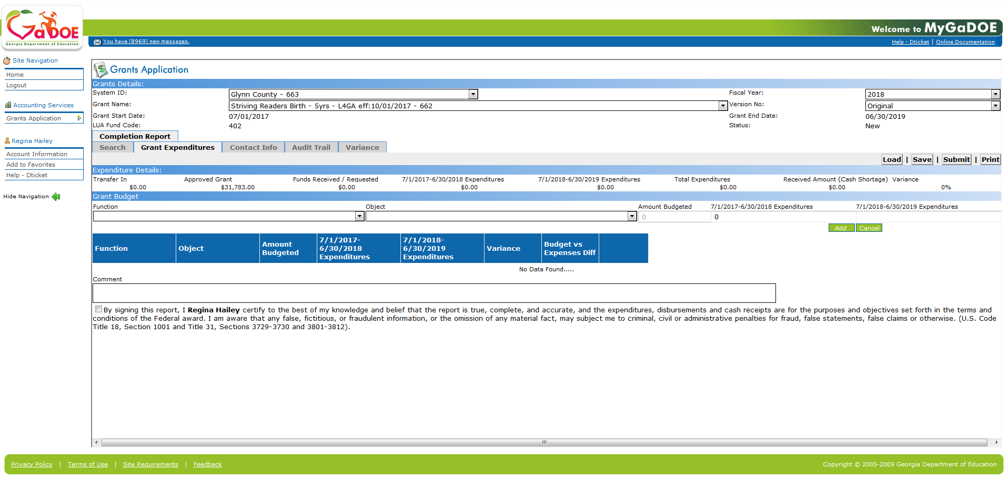

- Select (Load).
The Load Process Import dialog box displays:
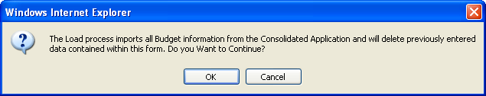
- After reviewing the information displayed, select (OK) to continue the load procedure, or select (Cancel) to return to the previously displayed Grant Expenditure tab.
The Load selection and data entry area displays:
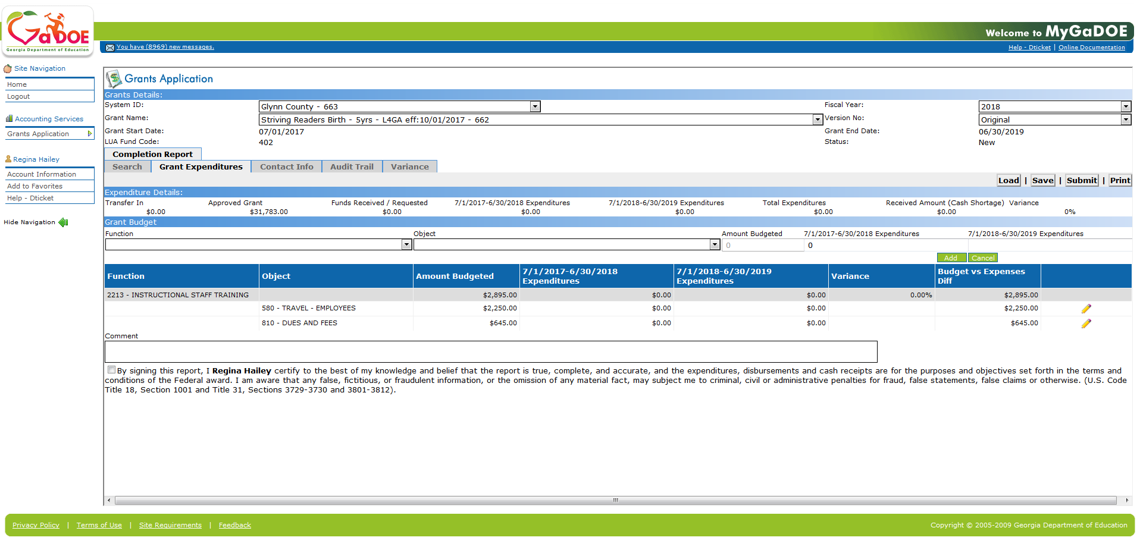
- Click on the for each line item,
The Grant Budget line item area displays:

- Enter the dollar amount of the expenditures within the 7/1/2017- 9 /30/2019 Expenditure and the 7/1/20017-9/30/2019 Expenditure fields where appropriate.
- Select (Update). You must click update after each entry.

The information added in Steps 9 – 10 displays:
Verify all data input.

- Using the right scroll bar, scroll down to the certification area of the page.
The certification area displays:
- Review the certification information displayed, and select the checkbox .

Step 3: Processing Contact Information
- Select the Contact Info tab.
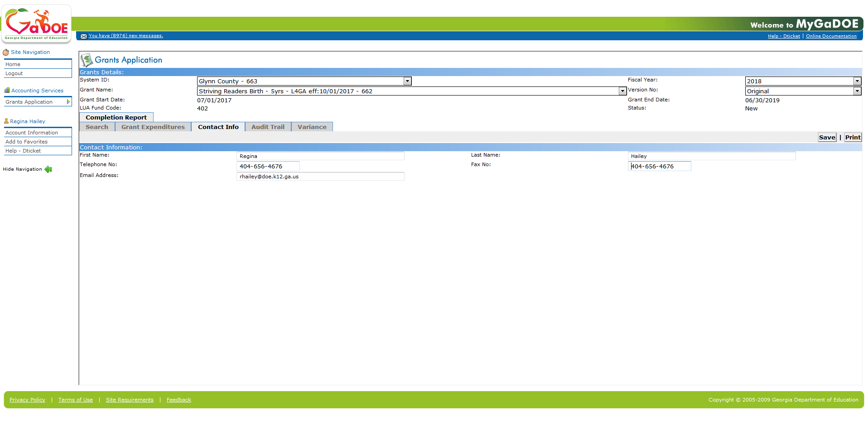

- Should display contact information for the person who is logged into the system.
- If not, enter the appropriate information within the First Name, Last Name, Telephone No (Telephone Number), Fax No (Fax Number), and Email Address fields.

- Select (Save).

Step 4: Viewing Audit Trail Information
- Select the Audit Trail tab.
The Audit Trail area displays:
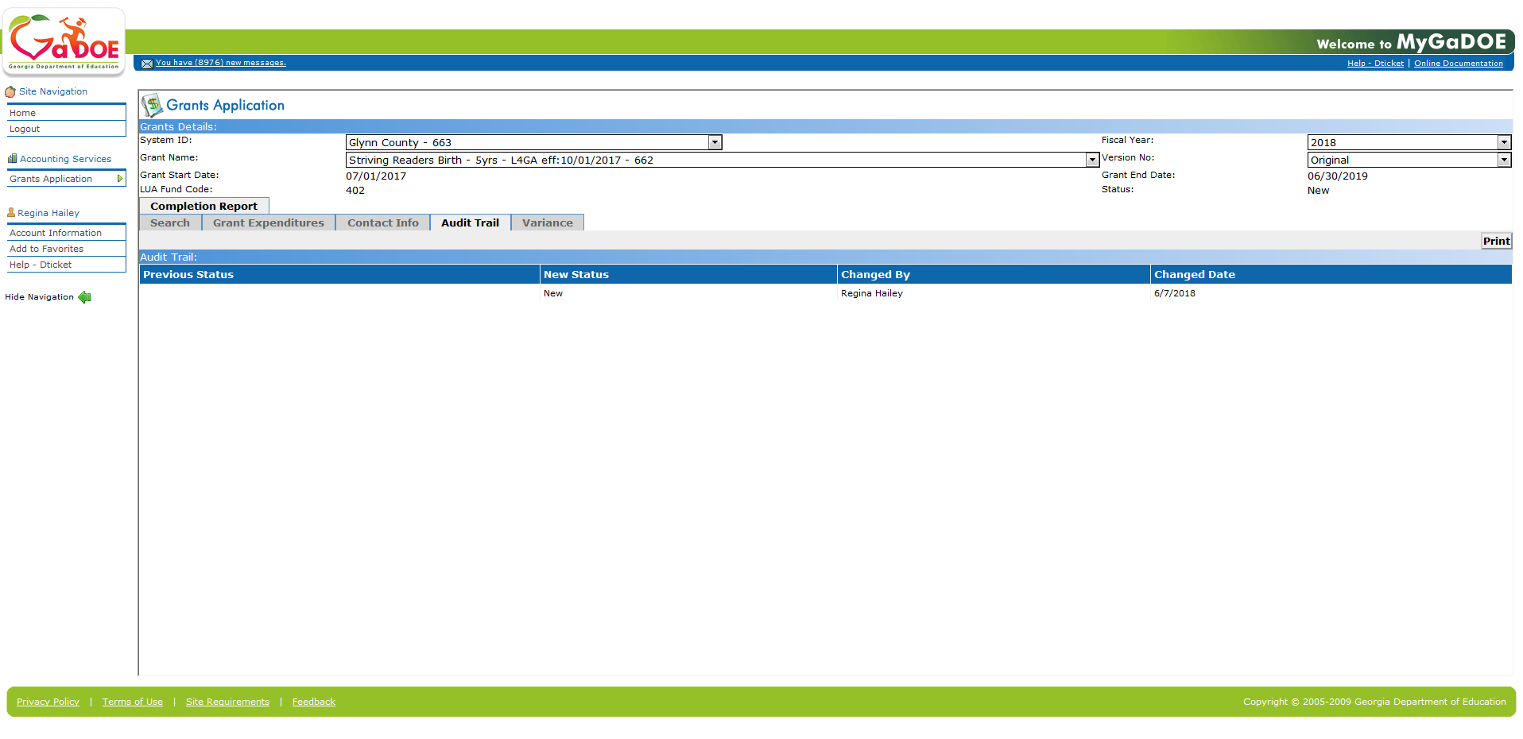

Step 5: Submitting Completion Report

- Select (Submit).

The Submission verification dialog box displays:
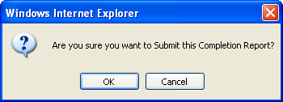
- Select (OK) to submit the report, or select (Cancel) to discontinue proce

